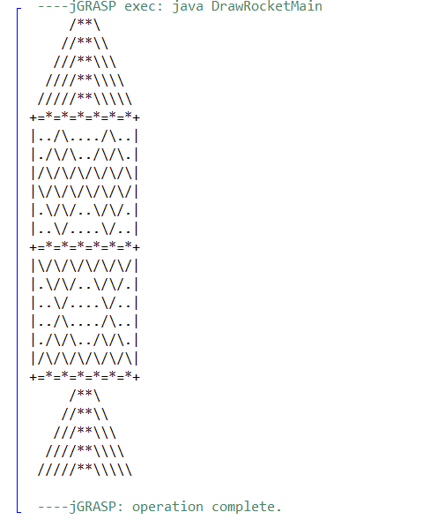

DrawRocketMain
DrawRocketHelper

Main
DrawRocket
DrawTop
DrawLine
DrawTopPart
DrawBottom Part

- DrawRocketHelper
- Main
  - Call the method that draws the full rocket
- DrawTop
  - Draws the cone on the top of the rocket
  - Use a nested for loop that makes it get wider as the lines go down
  - Make it so it can be reused at the bottom of the rocket for the smoke
- DrawLine
  - It gets reused three times in the code
  - Draw the line that separates the section
- DrawTopPart
  - Draws the first main section of the rocket
  - Change the amount of slashes and dots in each line to make a pattern
- DrawBottomPart
  - Draw the bottom section of the rocket
  - Make a loop similar to the top part but with a different pattern
- DrawRocket
  - Combine the 4 previous loops into one method to create the full rocket
- RocketMain
  - Calls the main method from the helper class to call the full rocket in one line

